**Restaurant Management System**

**DBMS Project -**

Made By:

V Tanish (RA1811003010749)

S Neel Lohit (RA1811003010750)

Pradhip Kumar (RA1811003010751)

Shanmukh Sai (RA1811003010752)

***Under the guidance of***

**Dr. M.S.Abirami**

***in partial fulfillment for the award of the degree of***

**BACHELOR OF TECHNOLOGY**

**in**

**COMPUTER SCIENCE & ENGINEERING**

**of**

**FACULTY OF ENGINEERING AND TECHNOLOGY**



**Abstract**

A restaurant management system is a collective term for software that helps streamline food business operations. Namely, restaurants, bars, bakeries, cafes, cloud (dark, virtual, ghost) kitchens, food trucks or delivery businesses.​

It combines all things that are good about the traditional POS (Point of Sale) systems, with tools that manage your phone calls, take table reservations, streamline inventory management, handle billing, provide actionable analytics, and also help with marketing activities such as CRM, loyalty programs and building an online presence. It also works seamlessly with your existing restaurant technology systems (your accounting and employee management software) and uses open APIs that let you integrate with any third party tool.​

​

**Acknowledgement**

We would like to express our special thanks of gratitude to my teacher (Dr .M. S Abhirami) who gave me the golden opportunity to do this wonderful project on the topic (DBMS project), which also helped me in doing a lot of Research and We came to know about so many new things. We are really thankful to them.

Secondly We would also like to thank my parents and friends who helped me a lot in finalizing this project within the limited time frame.

**Schema** 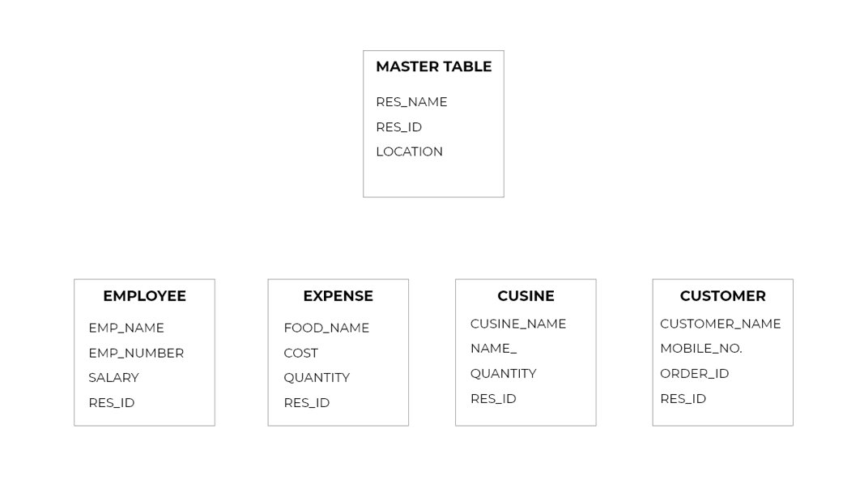

**Table Distribution**

* **Master Table- Tanish​**
* **Employee Table-Neel​**
* **Expense Table-Tanish​**
* **Cuisine Table-Shanmukh ​**
* **Customer Table- Pradhip**

**Project Implementation**

**Master Table: (V Tanish)**

Create the table



Alter the table

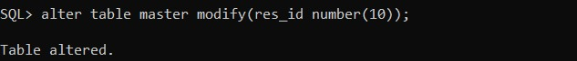

Inserting values

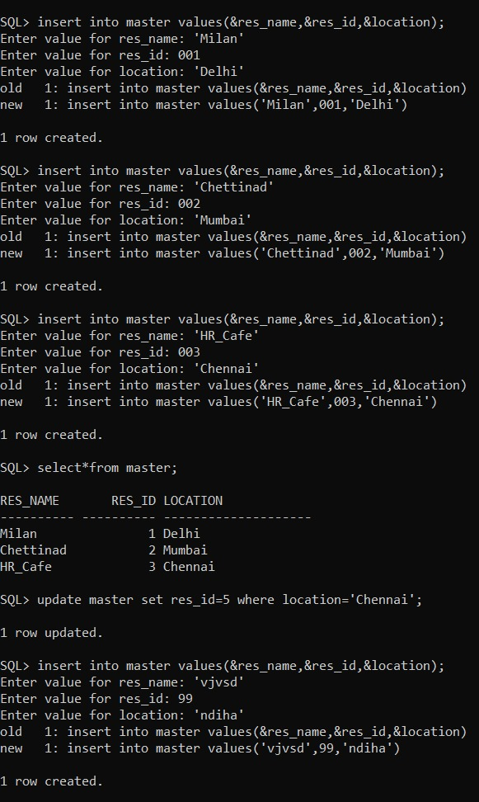

DML on master table

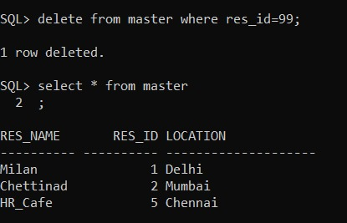

Adding constraints



Committing changes into master table

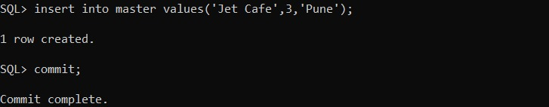

Selecting using operators

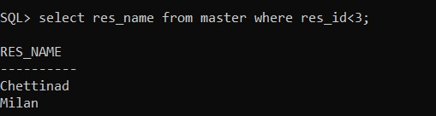

Using operators

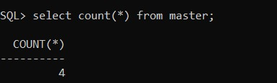

Using Pl/Sql

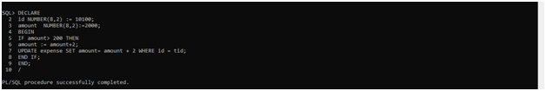

Creating Triggers and using them

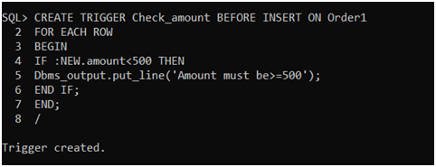

Creating view

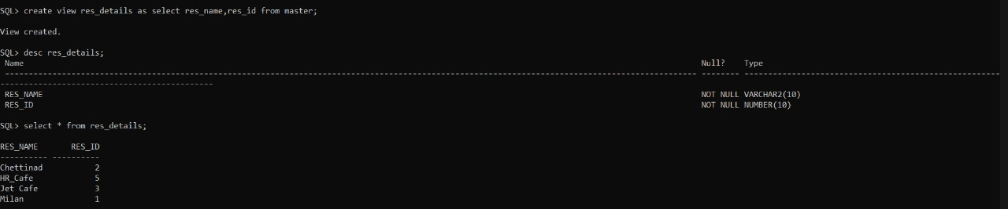

Creating Exceptions

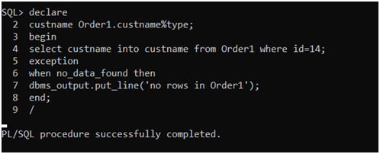

**Expense Table: (V Tanish)**

Creating the table



Modifying the table



Inserting values into the table

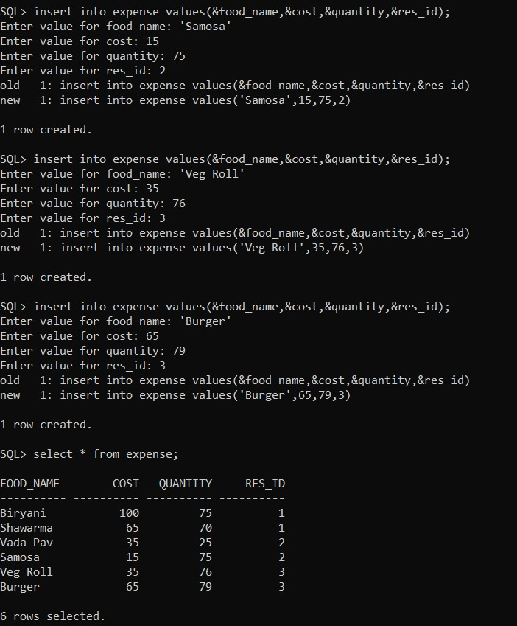

Selecting values in the table using operators

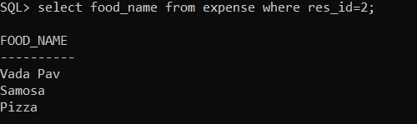

Adding constraints



Using commit to make changes

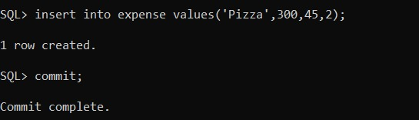

Using various function to select the values

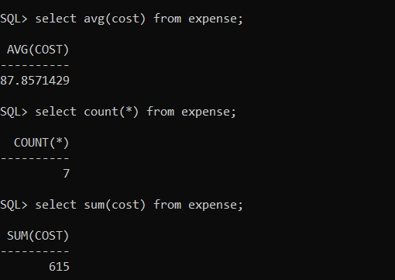

Creating views

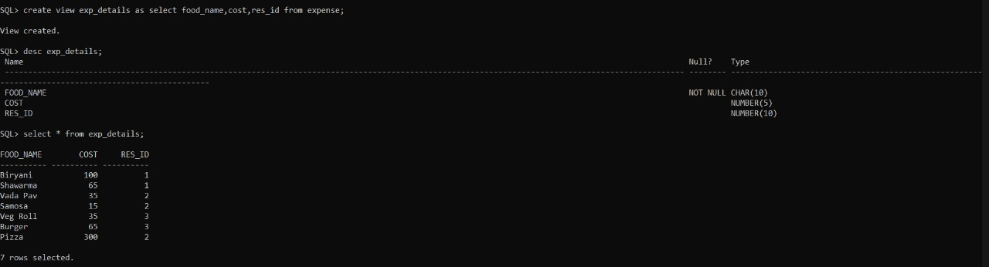

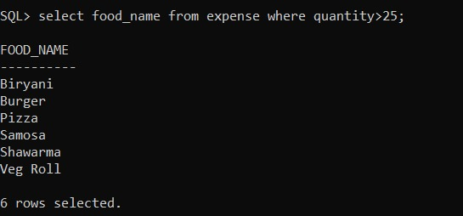

Using PL/SQL



Creating Triggers



Creating exceptions



**Employee Table: (Neel Lohit)**

Creating table and inserting values

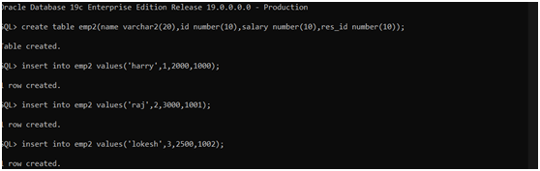

Updating tables

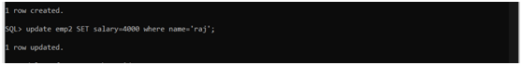

Delete and Applying various DML operations

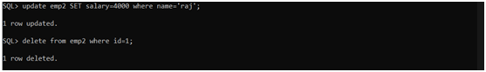

Altering Table

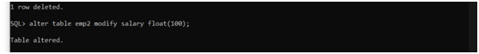

Using savepoint and rollback

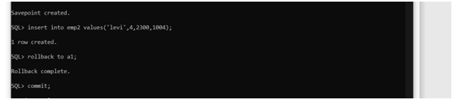

Using group functions

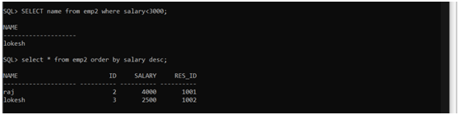

Using various functions to select values

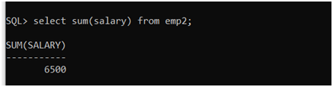

Using MIN MAX operations

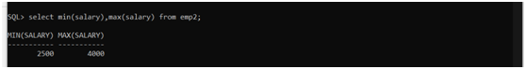

Applying Join Operations

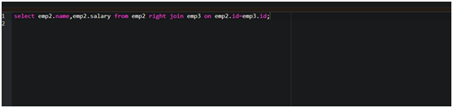

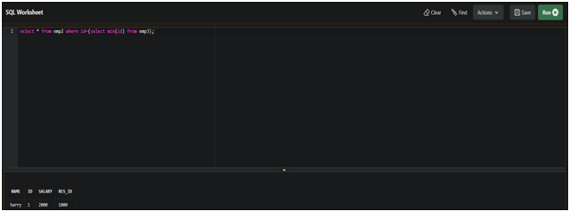

Creating view and using it

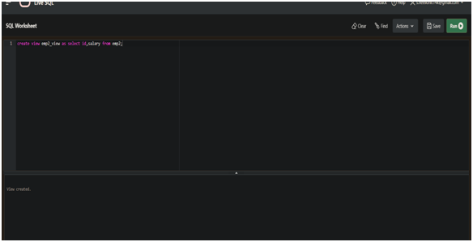

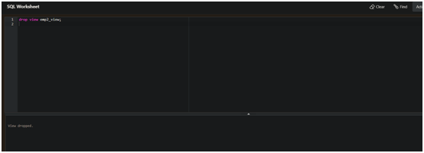

Using PL/SQL Blocks

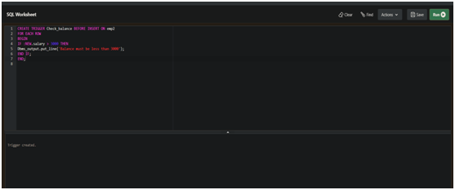

Creating Triggers

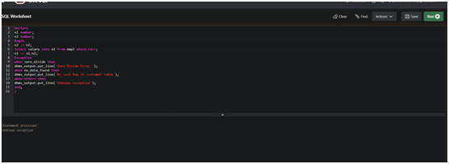

Creating exceptions

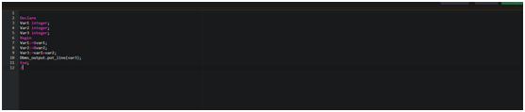

**Customer Table: (Pradhip Kumar)**

Creating Table and inserting values

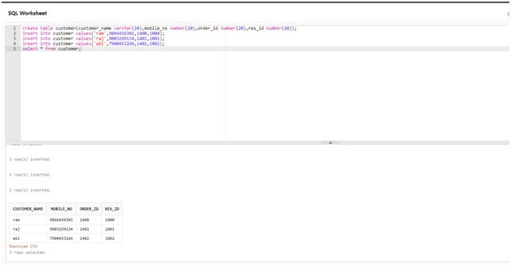

Updating Table

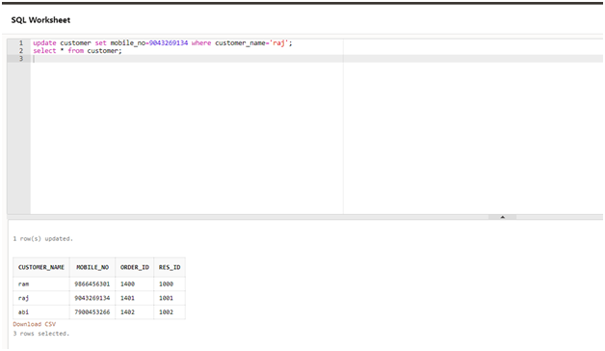

Using DML Commands

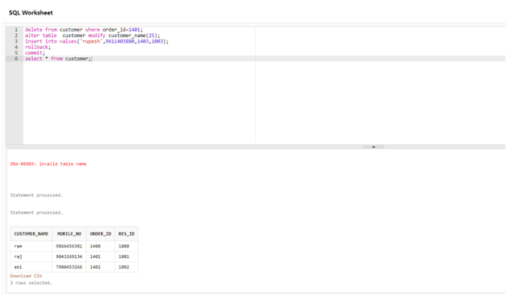

Selecting various values using operators

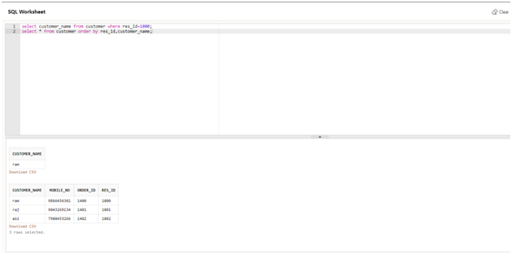

Using distinct functions

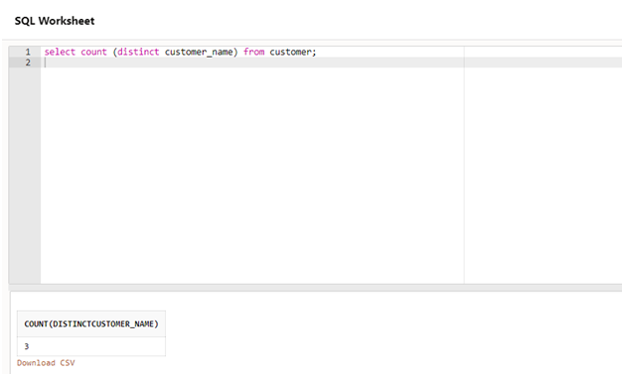

Applying join operations

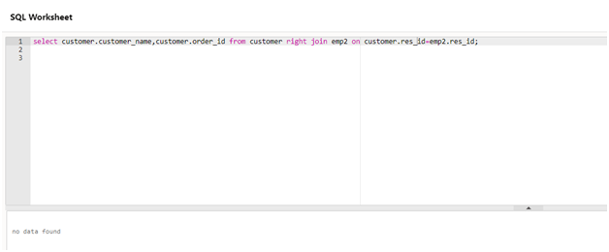

Selecting values using subqueries

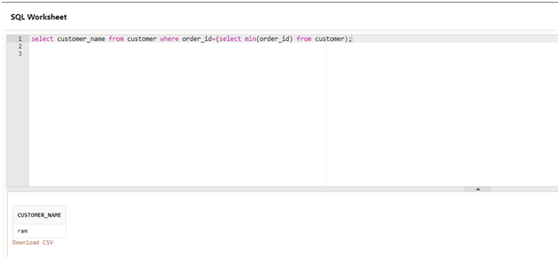

Creating views and using them

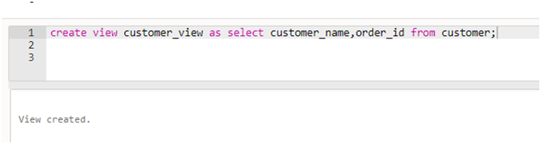

Dropping views

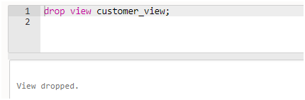

Creating Triggers

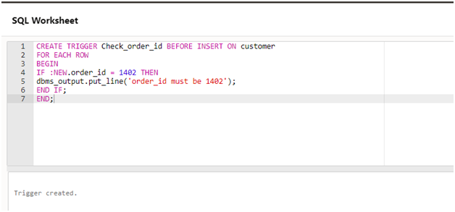

**Cuisine Table: (Shanmukh Sai)**

CREATE CUISINE TABLE AND INSERT VALUES

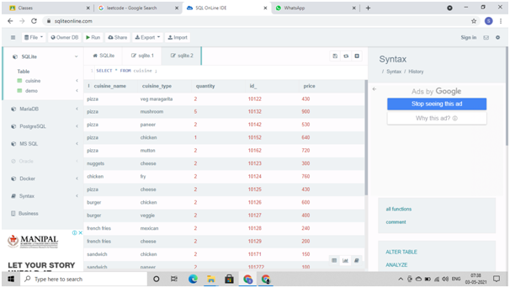

SELECT CUSINE GREATER THAN 500

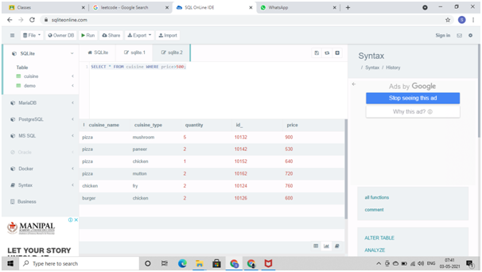

SELECT THE MIN PRICE CUSINE

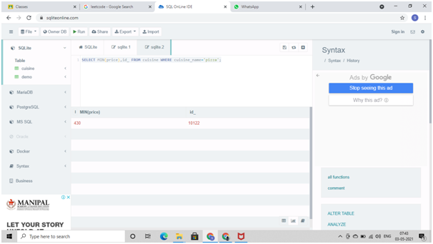

SELECT AVERAGE PRICE OF CUSINE

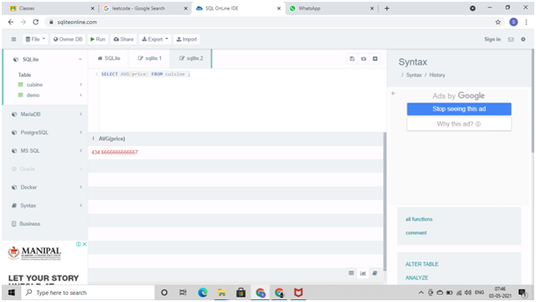

SELECT CUSINE ACCORDING ACENDING ORDER

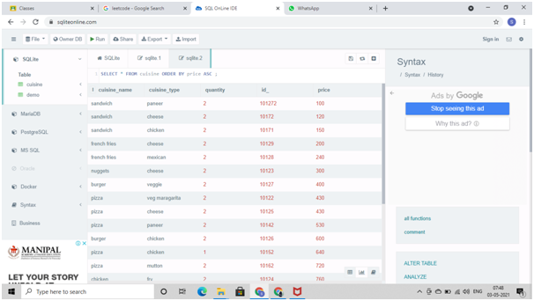

UPDATED CUISINE MENU

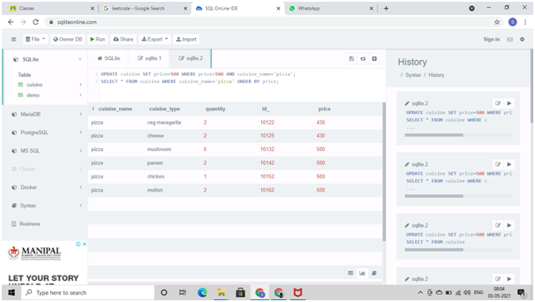

USING PL/SQL

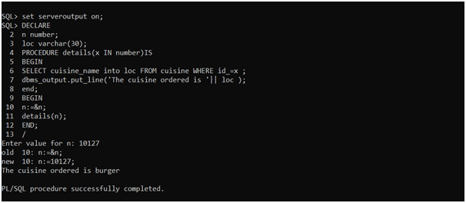

**Conclusion**

In conclusion the restaurant management system will go a step further and define it is a software stack that helps restaurants grow.​

* By helping restaurants:​
* Reduce the order processing time.​
* Automate redundant work.​
* Deliver a great customer experience.​
* Determine Profits & Costs​.

While developing this project we have learnt a lot about database management, we have also learnt how to make the application user-friendly (easy to use and handle) by hiding the complicated parts of it from the users.

​